Marcus Want to Claim That Exhibit G Should Be Sealed. However, this information is already in the public domain:
https://x.com/immutablechrist/status/1819048417324077249/video/1
https://x.com/immutablechrist/status/1819047450222469500/photo/1
https://x.com/immutablechrist/status/1819047450222469500/photo/2
https://x.com/immutablechrist/status/1819047450222469500/photo/3
https://x.com/immutablechrist/status/1819047061217550357/photo/1
https://x.com/immutablechrist/status/1819047061217550357/photo/2
https://x.com/immutablechrist/status/1819047061217550357/photo/3
https://x.com/immutablechrist/status/1819043021444268388/photo/1
https://x.com/immutablechrist/status/1819043021444268388/photo/2
https://x.com/immutablechrist/status/1819043021444268388/video/3
https://x.com/immutablechrist/status/1819043021444268388/photo/4
https://x.com/immutablechrist/status/1819038058416615681/photo/1
https://x.com/immutablechrist/status/1819032288027410888/photo/1
https://x.com/immutablechrist/status/1819027774914351233/photo/1
https://x.com/immutablechrist/status/1817987537060905402/photo/1
https://x.com/immutablechrist/status/1817987537060905402/photo/2
https://x.com/immutablechrist/status/1817987537060905402/photo/3
https://x.com/immutablechrist/status/1817903162361082363/video/1
https://x.com/immutablechrist/status/1817245008069804067/video/1
https://x.com/immutablechrist/status/1817245008069804067/video/2
https://x.com/immutablechrist/status/1817245008069804067/photo/3
https://x.com/immutablechrist/status/1816106797322719341/video/1
https://x.com/immutablechrist/status/1816106797322719341/video/2
https://x.com/immutablechrist/status/1815779951330623813/photo/1
https://x.com/immutablechrist/status/1815779951330623813/photo/2
https://x.com/immutablechrist/status/1815026109026652554/photo/1
https://x.com/immutablechrist/status/1771223307481718949/photo/1
https://x.com/immutablechrist/status/1771243214080544979/photo/1
https://x.com/immutablechrist/status/1815455326667227488/photo/1

https://immutabletruthelections.substack.com/p/she-lied-pinellas-county-supervisor
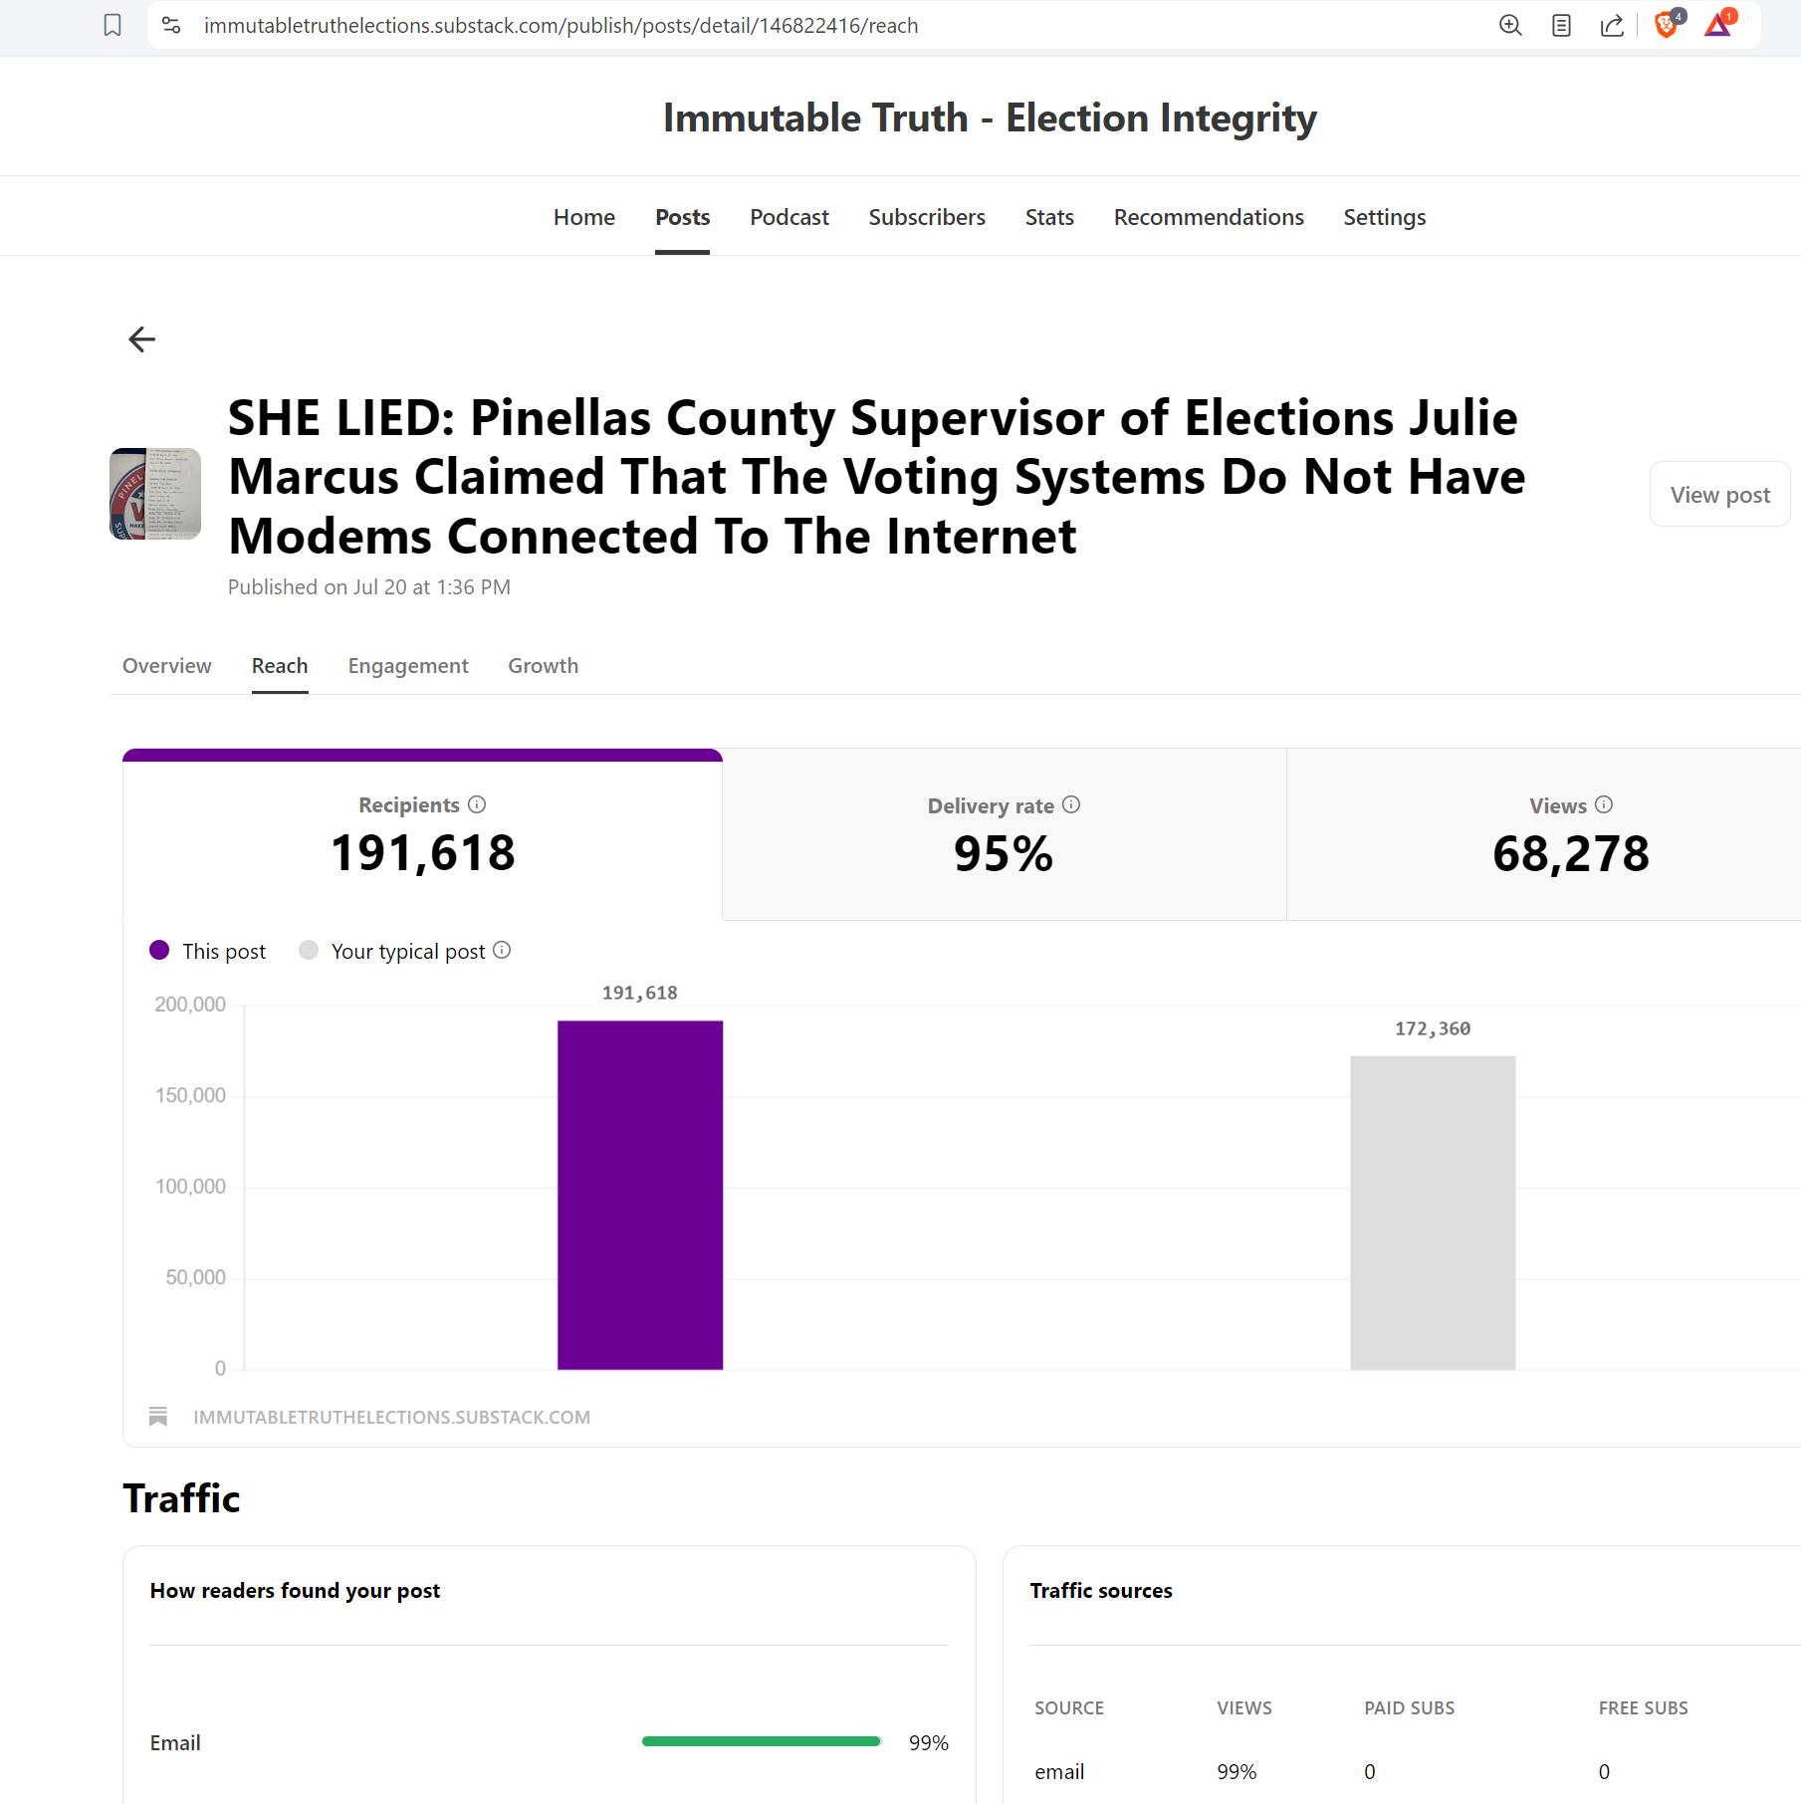
This article was originally published on July 20 at 1:36 PM
191,618 people received this article via email.

Moreover, according to SEMRUSH the article at the following
Subdomain: https://immutabletruthelections.substack.com/p/shelied-pinellas-county-supervisor
Has approximately 8,000+ Backlinks
203 – referring IP Addresses
133 – Referring Domains

Numerous of the Exhibits that Marcus falsely claims as “Sensitive Information” have been widely disseminated are are in the public view. See the Statistics from the Substack account published by the Plaintiff:
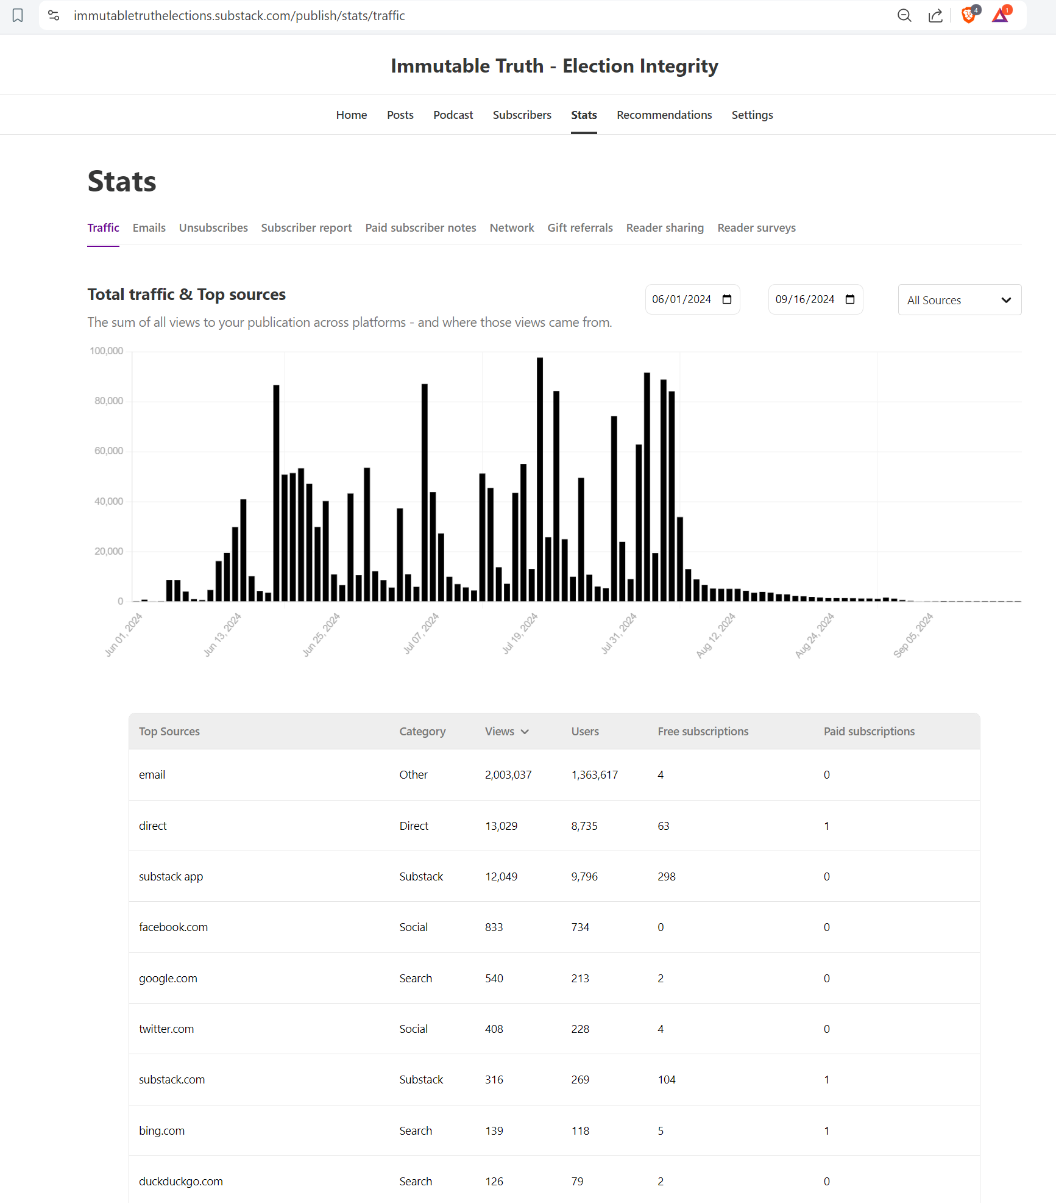

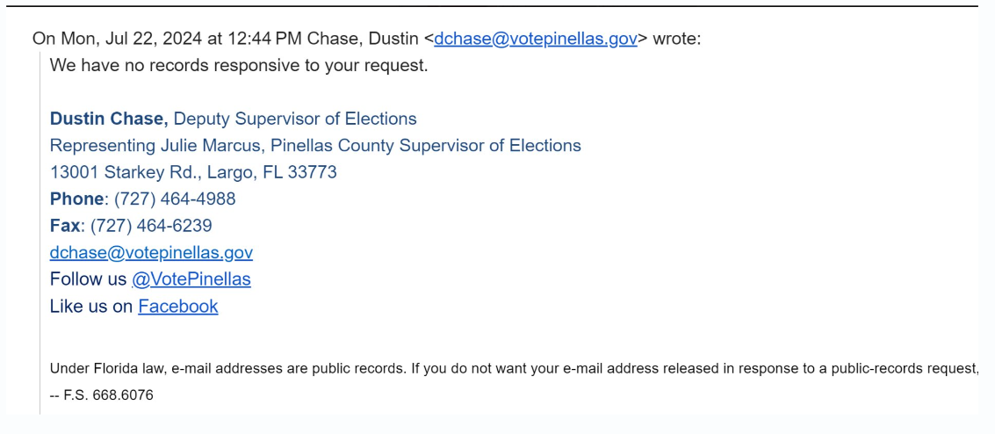
668.6076 Public records status of e-mail addresses; agency website notice.—Any agency, as defined in s. 119.011, or legislative entity that operates a website and uses electronic mail shall post the following statement in a conspicuous location on its website:
Under Florida law, e-mail addresses are public records. If you do not want your e-mail address released in response to a public records request, do not send electronic mail to this entity. Instead, contact this office by phone or in writing.

https://www.eac.gov/sites/default/files/2023-08/ES%26S%20EVS%206.4.0.0%20Certificate%20and%20Scope%20of%20Conformance%20Signed%20%282%29.pdf

